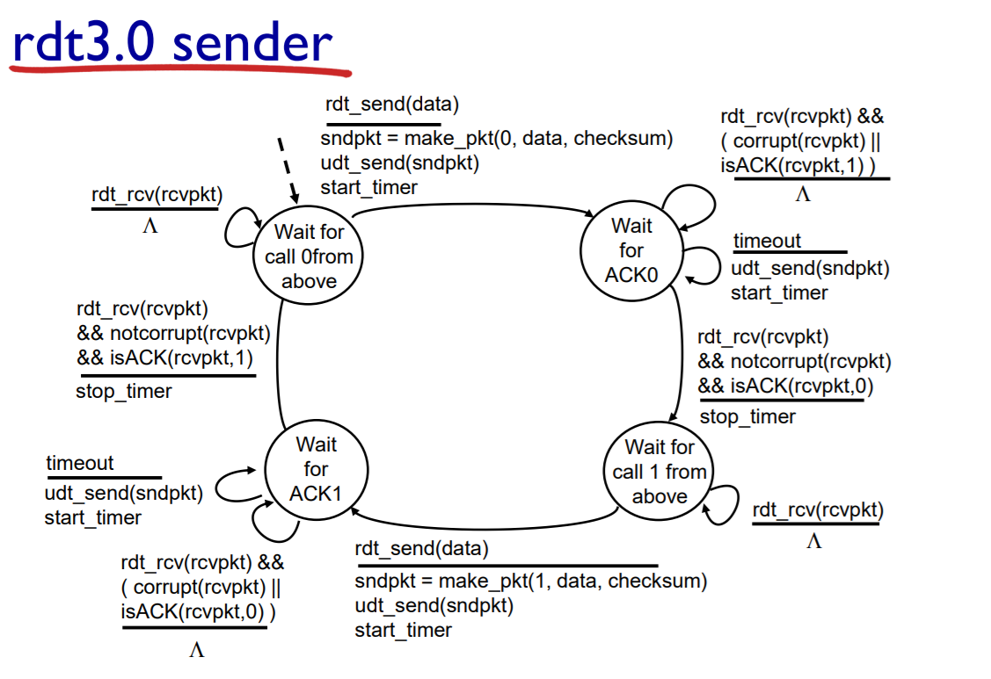

Receiver:

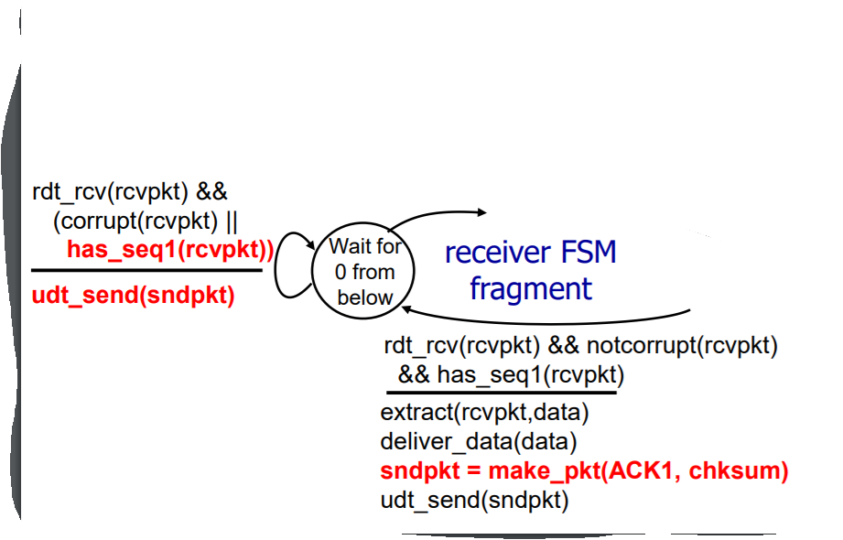

Pipeline protocols

two method to solve error in pipline are Go-back-N and Selective Repeat

(GBN & SR)

回退N步：

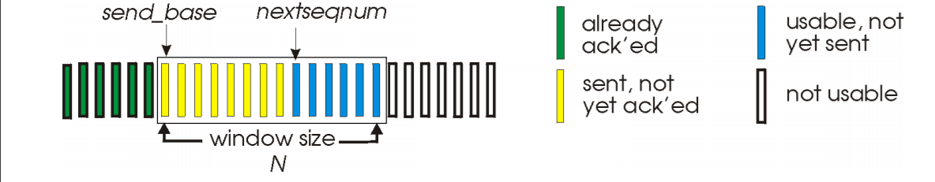

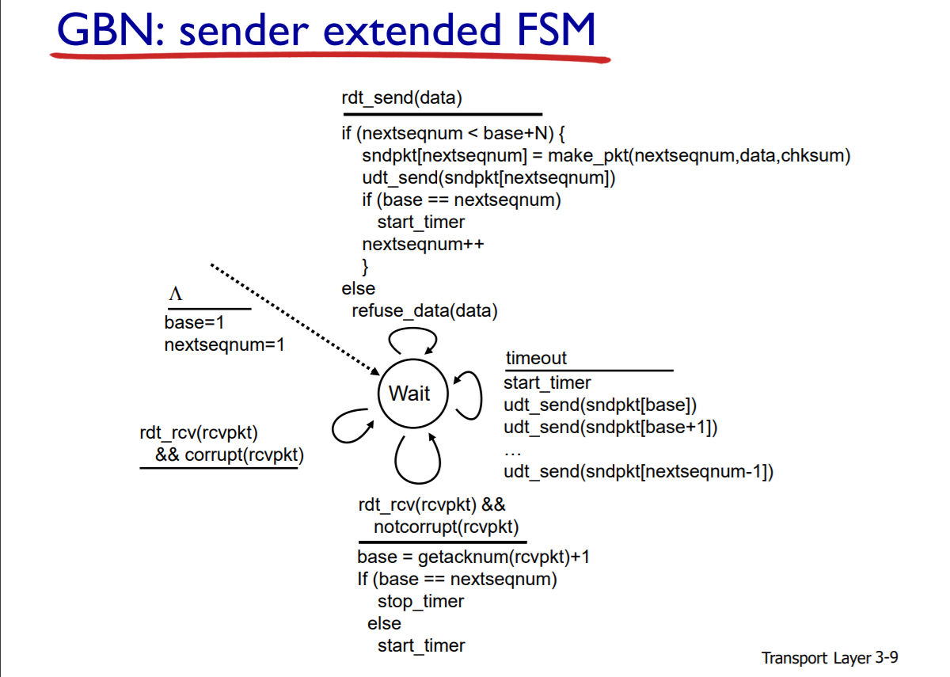

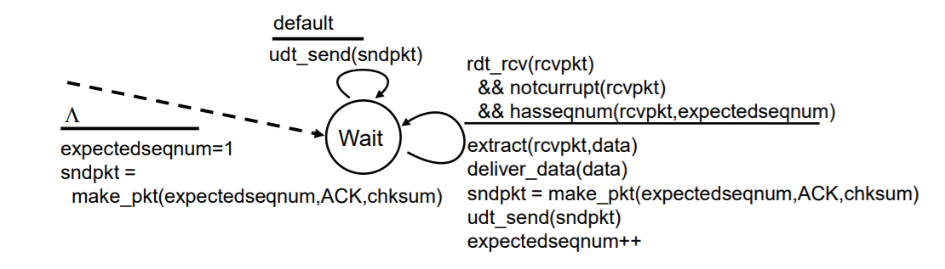

选择重传：

